Cave Aragonite in NSW, Australia
Jill Rowling
2 Derribong Place, Thornleigh NSW, Australia 2120.
rowling@ali.com.au

Abstract
Aragonite is unstable in fresh water and usually reverts to calcite, but it is actively depositing in some caves in New South Wales (NSW), Australia. Several factors were found to be associated with the deposition of aragonite speleothems in NSW caves. They include the presence of ferroan dolomite, calcite-inhibitors and both air movement and humidity. Several NSW caves were examined for aragonite, concentrating on sites at Jenolan, Wombeyan and Walli. Aragonite at Jenolan Caves is precipitated as anthodites, spathites, helictites, cavity fills, vughs and coatings. The substrate for the aragonite is porous, altered, dolomitised limestone which is wedged apart by aragonite crystals. At some sites, pyrite occurs in the dolomite. Calcite-inhibitors at Jenolan are mainly minerals containing ions of magnesium, manganese, sulfate and to a lesser extent, phosphates. Aragonite, dolomite and rhodochrosite are being actively deposited in Contact Cave. During winter, cold dry air pooling in the lower part of some caves may concentrate minerals by evaporation. Aragonite formed under these conditions tends to have fine crystals due to more rapid precipitation, whereas aragonite formed in more humid areas tends to have larger crystals. Aragonite at Wombeyan Caves is less common than that at Jenolan. The calcite-inhibitors are similar to those at Jenolan, sourced partly from bedrock veins and partly from breakdown of minerals in sediments sourced from mafic igneous rocks. Air movement may assist in the rapid exchange of CO2 at speleothem surfaces. At one low-humidity site, the presence of vaterite and aragonite in fluffy coatings infers that vaterite may be inverting to aragonite. Aragonite at Walli caves is associated with gypsum and barite veins, coatings containing calcite-inhibitors and, in some areas, low humidity. Calcite-inhibitors include sulfate (mostly as gypsum), magnesium, manganese and barium. The source of these calcite-inhibitors appears to be weathering of ferroan dolomite and pyrite in chert nodules.
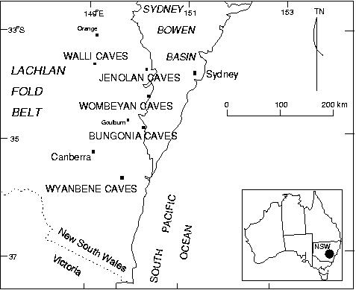
Figure 1: Part of NSW showing tectonic regions and cave areas. Map bases: NSW Dept. Mineral Resources and Geosciences Australia.
Introduction
Aragonite is a polymorph of calcium carbonate, CaCO3, actively depositing in many limestone caves around the world (Hill & Forti 1997). Most speleothems in NSW caves are calcite, and aragonite is minor. Calcite is the more common polymorph encountered, as the cave environment is well within the pressure-temperature stability region for calcite. Calcite inhibitors are substances which disrupt the calcite crystal lattice (crystal poisoners) by physically blocking calcite growth points, allowing aragonite to precipitate instead. Morse (1983) listed the following ions as calcite inhibitors: Mg, heavy metals and rare earths (Cu, Sc, Pb, La, Y, Cd, Au, Zn, Ge, Mn, Ni, Ba, Co), SO4, and PO4. Mg is particularly influencial on the precipitation of aragonite (Curl 1962). Studies on aragonite in NSW caves began in 1892, but little scientific work was done until the mid 20th century (Rowling 2005). In show caves, aragonite is valuable as an attractive or unusual tourist showpiece. The main sites examined were at Jenolan, Wombeyan and Walli, all located in the Lachlan Fold Belt tectonic region (Cas 1983) - Figure 1.

Methods
Caves are non-renewable, fragile environments and it is important to preserve the appearance of the sampled site. Speleothems are classified as per Hill & Forti (1997). Cave temperature, relative humidity and CO2 concentrations were measured. Samples were examined using optical microscopy and scanning electron microscopy (SEM), with a Philips SEM505. X-Ray Diffraction (XRD) was the primary diagnostic tool for identifying minerals, using a 3kW Siemens Kristalloflex 710D X-Ray generator, model 7kP5000-8AE, with a Siemens D5000 Diffractometer. Generator: 40kV, 40mA, Cu target. Slits: 1 mm at source, 1 mm, 0.2 mm, 0.6 mm (at receiver). Monochromator: graphite crystal (2d = 0.2708 nm) for Cu Kα radiation. Kβ filters: nickel, 12 μm thickness. Scans: 2 to 70° 2θ in 28 minutes (2.4° / minute). All XRD and SEM work was done at the Electron Microscope Unit at the University of Sydney.
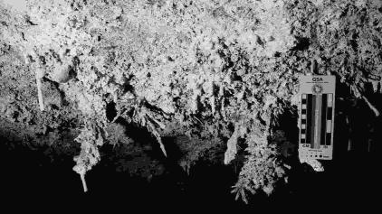

Figure 2: Anthodites in Contact Cave
Jenolan Caves
Jenolan Caves are a world-famous tourist destination, about 110 km west of Sydney (Figure 1), on a dissected plateau with an average elevation of 1100 m ASL. The caves are situated in a north – south trending band of Silurian sediments, volcanics and limestone. The limestone crops out as a narrow band, and is intruded by several dykes. The limestone generally dips to the west, overturned in most areas, with almost-vertical bedding near the show cave complex, more shallow bedding (overturned) to the north and is crossed by several faults. Most caves at Jenolan contain calcite speleothems, and some have aragonite.
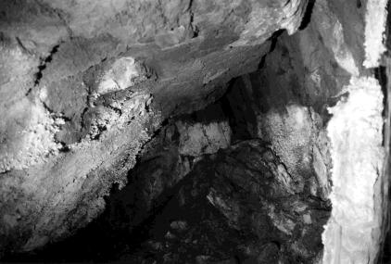

Figure 3: "Popcorn Line", Contact Cave
Contact Cave
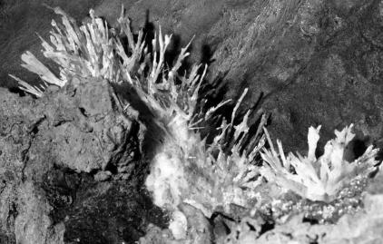
Contact Cave is a small cave near the eastern edge of the limestone north of the show caves. The original limestone micrite has been preferentially replaced with ferroan dolomite, with larger bioclasts unaltered by dolomitisation. Aragonite in the lower part of the cave occurs either as a ceiling coating (associated with substrate crystal wedging) or as stalactitic forms such as anthodites along joints (Figure 2). Minerals associated with aragonite include dolomite and rhodochrosite and others containing ions of Fe, Mg, Mn, CO3, SO4 and PO4. Bat guano is a suggested source of the PO4. Aragonite deposition in Contact Cave is enhanced by the calcite-inhibitors Mg, Mn, and to a lesser extent, PO4. During winter, cold dry air pooling in the lower part of the cave may concentrate minerals on the stalactites and walls by evaporation, leading to a “popcorn line” in the cave (Figure 3). Possibly strong acid (e.g. H2SO4) released from the slow oxidation of pyrite in the thinly-bedded limestone and ferroan dolomite above the cave releases Mn and Mg from the bedrock. These seep into the cave, react with carbonates and outgas CO2 to precipitate as speleothems.

Figure 4: Anthodite on ochre, Wiburds Lake Cave

Wiburds Lake Cave
Wiburds Lake Cave is near the northern end of the limestone outcrop. Fault zone breccias of sheared chert and mudstone crop out, and a faulted mafic dyke is exposed in parts of the cave. Its 7 km of passages are guided both by faulting and the strike of the bedding. Near the entrance are coatings, helictites and small anthodites, comprising gypsum and aragonite, minor pyrolusite, kaolinite and hydromagnesite, and trace calcite and huntite (XRD). A chamber in the northern area of the cave, far from the entrance, has a dyke in its ceiling, sheared bedrock, and aragonite speleothems. These include a spathite, and anthodites with an ochre substrate (Figure 4).
Aragonite is associated with calcite inhibitors Mn, Mg and SO4. Small aragonite “stars” are associated with a red gelatinous material in sediment, possibly bat-guano derived, comprising diadochite and epsomite with organics, sediments and other phosphates. SO4 may be derived either from the bat guano or from oxidising pyrite in the dyke.

Other Caves at Jenolan
Glass Cave contains aragonite-like speleothems associated with gossans and minerals containing Mg and PO4. Aragonite has been confirmed from the following show caves: River Cave, Mud Tunnels and Ribbon Cave (Osborne 1999, Osborne, Pogson & Colchester 2002, Rowling 2005). Aragonite-like speleothems have been reported from several others. Forms taken include spheroids (“stars”), helictites, and white and brown “furze bushes” - tight combinations of stalactite, column, stalagmite, beaded helictites and flos ferri, often associated with huntite and hydromagnesite. The substrate to the show cave aragonite speleothems is typically red ochres and dolomitised limestone or dolomitic palaeokarst. In Mammoth and Spider Caves, aragonite-like speleothems have developed on possibly dolomitised substrates and with minerals containing Mg, Mn and possibly SO4.

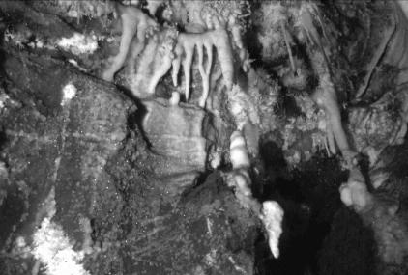
Wombeyan Caves

Figure 5: Aragonite Canyon view
Wombeyan Caves are about 130 km to the south-west of Sydney and about 19 km west of the western edge of the Sydney Basin (Figure 1). The caves have formed in saccharoidal marble, in an irregular area completely surrounded by effusive silicic to intermediate igneous rocks and intruded by gabbro and granite. The marble features dyke-like joints filled with pyroclastic material (Osborne 1993]. The area forms a broad basin surrounded by steep hills, and is part of the Sydney catchment. There are about 500 speleological features, including six well-decorated show caves.

Sigma Cave
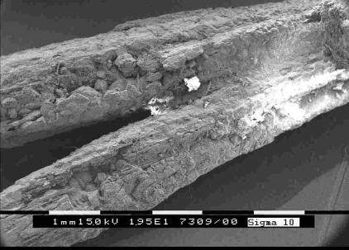
Sigma Cave is in the south-east of the marble outcrop, near a gabbro intrusion. It has about 3 km of passages forming an overall branching pattern, developed along joints and also possibly the strike of the original bedding. Aragonite and aragonite-like speleothems occur in several places, but mainly at Aragonite Canyon far from the entrance (Figure 5). Aragonite occurs as a prickly wall coating on marble bedrock and on mud, on walls and fringing edges of holes where breezes are felt. Aragonite forms include skeletal coralloids, anthodites, helictites, stalagmites and spathites. Substrates include fine gravel, mud, marble and moonmilk. Mineral associations with aragonite include calcium silicates, clays, calcite, magnesian calcite, phosphates, epsomite, whewellite, hydromagnesite and huntite (XRD). “Twigs” fallen from a helictite “bush” comprise calcite, minor magnesian calcite, aragonite and hydromagnesite, with traces of huntite and kaolinite (XRD). The original aragonite structures are preserved in the shape (Figure 6). The most likely source of silicates is gabbro in the gravel, altered by bat guano.

Figure 6: "Twig" (SEM photo). Aragonite laths coated with Mg-rich minerals.
The spiky central canal of a small stalactite includes aragonite (XRD). Elsewhere, aragonite-like speleothems include 3-horned helictites, a saw-shaped helictite and small splinters on a dyke-like filled joint. Cave coralloids have depressions in their centres filled with needle crystals (possibly aragonite) and white pasty “moonmilk”. Small (1 cm to 4 cm diameter) “cave turnips” have broken open naturally, possibly by gas build-up. Inside the speleothem is a radially arranged hollow sphere of needle crystals, resembling aragonite, with a centre of mud with white “moonmilk”. The air in the cave is humid (>98% RH) and has mildly elevated CO2 (0.3 to 0.5%) ascribed to organic decomposition.

Wollondilly Cave
Wollondilly Cave is a show cave with two entrances and mainly calcite speleothems. Aragonite-like anthodites occur in The Cathedral, and an aragonite-like (calcite) coating occurs in a pool. Aragonite has been positively identified in two sites near the middle of the cave. Air movement in both sites is slight but noticeable. Aragonite was found as a minor mineral in small speleothems in Star Chamber, and in The Loft where the relatively humidity is low (76%, 16°C). Cobbles and gravel on the floor comprise weathered fragments of porphyry and clays altered by ancient bat guano. Aragonite is a minor component of coatings, and in a white to creamy yellow and orange fluffy fungus-like material present on the fine gravels (mainly needle-form calcite with vaterite, aragonite and other minerals). Calcite-inhibitors associated with aragonite in Wollondilly Cave include Mn, Mg, PO4 and SO4. Other caves at Wombeyan contain aragonite or aragonite-like speleothems, such as coralloids, “cave turnips” and coatings, sometimes associated with dolomitic bedrock.

Walli Caves
Walli Caves are located about 215 km west of Sydney in an area of gently rolling, rounded hills at about 440 m ASL and are part of the Lachlan catchment (Murray-Darling system). The caves are located in the western part of a faulted, 460 m thick foetid Ordovician limestone deposit and are relatively warm (19°C) compared with the average annual temperature of 16°C. About 4 km northeast of Walli Caves is a warm spring (28.5°C). The limestone is dolomitised in places (to dolomite and ankerite), and contains veins of barite, quartz and chalcedony, and dolomitised chert nodules with barite, anhydrite, goethite, pyrite and other metal sulfides. Cave outlines vary from branching to networks, formed around the local joint and fault pattern, with bedding influencing some passage cross sections. Gypsum occurs in the caves, usually as a coating on the limestone and as selenite needles on the surface of exposed chert nodules. Two caves were examined, Deep Hole and Piano Cave, both located in the southern area of the limestone outcrop. Although aragonite is not common at Walli, there are two types: a fine crystalline type associated with low humidity and a more coarse crystalline type in a humid area associated with mineralised veins and faults. Calcite-inhibitors associated with aragonite and low humidity include Mg and SO4 as epsomite (MgSO4) and gypsum. In humid areas small orange aragonite efflorescences have developed along seams associated with barite, gypsum, hexahydrite (MgSO4.6H2O), pyrolusite and traces of other barium minerals (XRD). Aragonite occurs where the bedding is very steep, or is cut by near-vertical faults, allowing oxygen-rich groundwater derived from rainfall to penetrate the beds, oxidise pyrite and mobilise ions.

Aragonite in other NSW caves
Large aragonite-like speleothems, identified by morphology alone, occur in a cave near Jaunter, west of Jenolan Caves. Aragonite in Flying Fortress Cave at Bungonia is associated with minerals containing Mg and Mn in an area with steeply-dipping, weathered dolomitised limestone beds close to a weathered dolerite dyke. Speleothems include small efflorescences, needles, hemispheres, crusts, flos ferri, spathites, curved and beaded helictites. Aragonite and aragonite-like speleothems in Wyanbene Cave are associated with a low-grade, disseminated base-metal ore body and dolomitised limestone. Speleothems include anthodites and coralloids. Aragonite-like helictites, small anthodites and coatings were reported from Colong Cave, southwest of Jenolan Caves. Aragonite-like speleothems at Wellington Caves, about 240 km NW of Sydney, are associated with phosphorite and some dolomitisation.

Conclusions
Calcium carbonate is depositing in NSW caves as aragonite wherever it cannot deposit as calcite due to chemical and physical factors, mainly calcite-inhibitors, with Mg present at most sites, usually the result of pyritic weathering of ferroan dolomite. Aragonite was associated with the following minerals which contain Mg: huntite, hydromagnesite, epsomite, dolomite, magnesian calcite, nesquehonite, lansfordite and hexahydrite.
Mn was also commonly present, possibly originating from the weathering of ferroan dolomite and weathering of ferromagnesian minerals from nearby mafic rocks. Aragonite was associated with the following minerals containing Mn: rhodochrosite, todorokite, pyrolusite, braunite, manganocalcite, manganoan calcite, rabbittite, birnessite and hausmannite.
SO4 was present in many sites examined. Three origins were suggested, one biological (bat guano) and two mineralogical (weathering pyrite and hydrothermal minerals). Biogenic sulfates were often associated with phosphates and vaterite. The following SO4-bearing minerals occurred with aragonite: gypsum, letovicite, epsomite, bassanite, natron and hexahydrite.
PO4 was present in some sites, and a bat guano origin is suggested. The following phosphatic minerals were associated with aragonite: diadochite, vauxite, koninckite, leucophosphite, arrojadite, variscite, collinsite, hydroxyapatite, ardealite, cacoxenite and heneuite.
Vaterite: CaCO3 was present in the form of vaterite, aragonite and needle-form calcite (“lublinite”) at some sites. It was suggested that these minerals were associated with old bat guano deposits, and that the aragonite in this case may be forming by inversion of vaterite to aragonite. Other minerals present contained Mg, Mn, SO4 and PO4.
Tectonic region: Possibly something in the geological history of the Lachlan Fold Belt has emplaced more dolomite and pyrite than in other regions.
Steeply-dipping beds, joints or faults: All sites have steeply-dipping beds, joints or faults, which may allow meteoric water to seep into the site and oxidise pyrite.
Mafic rocks: Weathering of mafic rocks may release calcite-inhibitors and may be assisted by oxidising pyrite and the corrosive effect of bat guano. Dykes may also host dolomite by mineral replacement during deep burial, e.g. the dyke in Wiburds Lake Cave. Filled joints may host calcite-inhibitors (e.g. in Sigma and Wyanbene Cave).
Association with ochres and gossans: Aragonite was associated with ochres and gossans in many sites examined, especially where the ochre appeared to be made of highly weathered ferroan dolomite. Calcite-inhibitors present in the ochres and gossans appear to have the most influence on whether aragonite is present or not.
Low Humidity: Aragonite was found in sites with high humidity and low humidity. In both cases, calcite-inhibitors were also present. Low humidity affects evaporation rate, which concentrates minerals containing calcite-inhibitors.
Air Movement: Aragonite was found both in sites with little air movement and sites with perceptible air movement. One effect of air movement is to increase the rate of exchange of CO2 between the speleothem and the air, allowing a higher rate of deposition than with still air. In areas with low humidity and perceptible air movement, evaporation rate is increased. In areas with high humidity and perceptible air movement, aragonite speleothems form filigree patterns such as frostwork. It is possible that the rate of deposition only affects the shape, and the mineralogy is dependent on the presence or absence of calcite-inhibitors.
Humidity contributes more to the form taken by the speleothem and less to the polymorph. In low humidity, crystal size is smaller and crystal orientation is more random as rate of deposition is faster. Forms taken by aragonite speleothems include irregular masses, very small helictites and simple coatings. In the case of high humidity, crystal size is generally larger and crystal orientation usually follows that of the substrate as rate of deposition is slow, forming anthodites, large helictites and spherulites.
In the caves examined, there was no correlation between aragonite and temperature (from 12.2°C to 18.8°C), CO2, pressure, clays, or strontium.

Implications for site management in show caves
As the aragonite polymorph is dependent on the presence of often soluble calcite-inhibitors, it is worthwhile preserving these minerals in order to preserve the aragonite speleothems in show caves. Cave cleaning often involves the use of water sprays; this method is not advisable in areas with aragonite, as without the calcite-inhibitors the material may revert to calcite. Other cleaning methods should be investigated. Dr Vaclav Cilek (pers. comm. 2004) also suggested tourists should not stand directly under cave aragonite, as lint and bacteria rising with body heat may damage the speleothem.

Acknowledgments
This article is a very short summary of my Master of Science thesis (Rowling 2004). I gratefully acknowledge the assistance of the following people and organisations: Dr Armstrong Osborne (School of Development and Learning, University of Sydney), the Electron Microscope Unit, University of Sydney for use of the electron microscope and X Ray Diffractometer, the School of Geosciences, University of Sydney for use of equipment. For permission to visit and sample, many thanks are made to the following organisations: Jenolan Caves Reserve Trust (Jenolan and Wombeyan Caves), The Sydney Speleological Society (Walli Caves), The NSW National Parks and Wildlife Service (Bungonia and Wyanbene), Wellington Shire Council (Wellington Caves). Thanks to members of Sydney University Speleological Society and Sydney Speleological Society for logistical support.

References
Cas, R. (1983), Palaeogeographic and tectonic development of the Lachlan Fold Belt southeastern Australia - Special Publication No. 10, Geological Society of Australia, Inc., Sydney, NSW Australia.
Curl, R. L. (1962), ‘The aragonite-calcite problem’, Bulletin of the National Speleological Society 24(1), 57–73.
Frank, R. (1974), ‘Sedimentary development of the Walli Caves, New South Wales’, Helictite pp. 3–30.
Hill, C. A. & Forti, P., eds (1997), Cave Minerals of the World, 2nd edn, National Speleological Society, Huntsville Alabama, USA.
Morse, J. W. (1983), The kinetics of calcium carbonate dissolution and precipitation, in R. J. Reeder, ed., ‘Carbonates: Mineralogy and Chemistry’, Mineralogical Society of America, pp. 227–264.
Osborne, R. A. L. (1978), ‘Structure, sediments and speleogenesis at Cliefden Caves, New South Wales’, Helictite 16(1), 3–32.
Osborne, R. A. L. (1993), ‘The history of karstification at Wombeyan Caves, New South Wales, Australia, as revealed by palaeokarst deposits’, Cave Science: Transactions of the British Cave Research Association.
Osborne, R. A. L. (1999), ‘The origin of Jenolan Caves: Elements of a new synthesis and framework chronology’, Proceedings of the Linnean Society of NSW 121, 1–27.
Osborne, R. A. L., Pogson, R. E. & Colchester, D. M. (2002), ‘Minerals of Jenolan Caves - Geosphere meets Biosphere (Abstract)’, Journal and Proceedings of the Royal Society of New South Wales 134 (3/4)(401 - 402), 111.
Rowling, J. (2004), Cave aragonites of N.S.W., Master of Science Thesis (unpubl.), The School of Geosciences, Division of Geology and Geophysics, The University of Sydney.
Rowling, J. (2005), ‘Studies on aragonite and its occurrence in caves, including New South Wales caves’, Journal and Proceedings of the Royal Society of New South Wales 137(3,4), 123–149.
Webb, J. A. & Brush, J. B. (1978), ‘Quill anthodites in Wyanbene Cave, Upper Shoalhaven District, New South Wales’, Helictite 16(1), 33–39.
Wilkinson, C. S. (1892), ‘Description of the Belubula Caves, Parish of Malongulli, Co. Bathurst’, Records of the Geological Survey of N.S.W. III(1), 1–5, plates I–III.

